**Introducing Bootstrap**

* Twitter Bootstrap is a popular front-end framework used to create responsive websites.
* Website creation through HTML and CSS requires a lot of effort and time.
* To address this problem, you can use ready-made pieces of code provided by Twitter Bootstrap.
* Twitter Bootstrap includes HTML and CSS-based design templates and JavaScript plug-ins to create the user interface components, such as forms, buttons, tables, navigations, dropdowns, alerts, and tabs.
* Bootstrap offers ready-to-use code that helps developers create responsive and mobile-first websites in a short period.
* Web developers do not have to spend a lot of time in writing code, instead, they can simply find the exact piece of code and fit it into their website.

**Advantages of Bootstrap**

* One of the important advantage of using Bootstrap is that it comes with a free set of components, such as navigation bar and other controls, which are used to create flexible and responsive Web layouts.

**Creating a Basic Bootstrap Web Page**

The following code snippet depicts the basic Bootstrap Web page:

<!DOCTYPE html>

<html lang="en">

<head>

<meta charset="utf-8">

<meta http-equiv="X-UA-Compatible" content="IE=edge">

<meta name="viewport" content="width=device-width, initial-scale=1">

<title>Basic Bootstrap Web Page </title>

<!-- Bootstrap -->

<link href="css/bootstrap.min.css" rel="stylesheet">

</head>

<body>

<h1>Hello, world!</h1>

<!-- jQuery (necessary for Bootstrap's JavaScript -ins) -->

<script src="js/jquery-2.1.1.min.js"></script>

<!-- Include all compiled plug-ins (below), or include individual files as needed -->

<script src="js/bootstrap.min.js"></script>

</body>

</html>

**Understanding Grid System**

In a graphic design, a grid is a structure made up of a series of intersecting straight lines used to structure content.

In the website development process, it is used to create the Web page layouts in the form of rows and columns that contain the website content.

Bootstrap uses a grid system that is based on a 12-column grid, where:

The width of each component of a Web page is specified in terms of the number of columns it occupies.

The width of any component cannot be more than 12 columns.

Bootstrap includes predefined classes that enable you to easily specify the layout.

Bootstrap requires a container to wrap everything contained in the Web page and to house the grid system

* **.container**
* You can use the .container class to create a container that is aligned in the middle of the screen.
* The width of the container depends on the size of the device.
* For example, for small devices, such as tablets, the width is 750px, whereas for medium devices, such as laptops, the width is 970px.
* You can create a container, as shown in the following code snippet:
* In the preceding code snippet, the .container class used in the <div> tag creates a fixed-width container that is aligned in the middle of the screen.

<div class="container">

<h1>Hello, world!</h1></div>

* Add the following code snippet in your stylesheet to set the   
  background-color property of the .container class:

***.container***

{background-color: #808080;}

* **.container-fluid**
* You can use the .container-fluid class to create a full-width container that spans the entire width of your viewport.
* The following code snippet shows how to use the .container-fluid class:

<div class="container-fluid">

<h1>Hello, world! </h1></div>

* In the preceding code snippet, the .container-fluid class is used in the <div> tag to create a full-width container that spans the entire width of your viewport.

**Understanding Grid System**

The layout of a Web page is usually created in the form of rows and columns, as shown in the following figure.

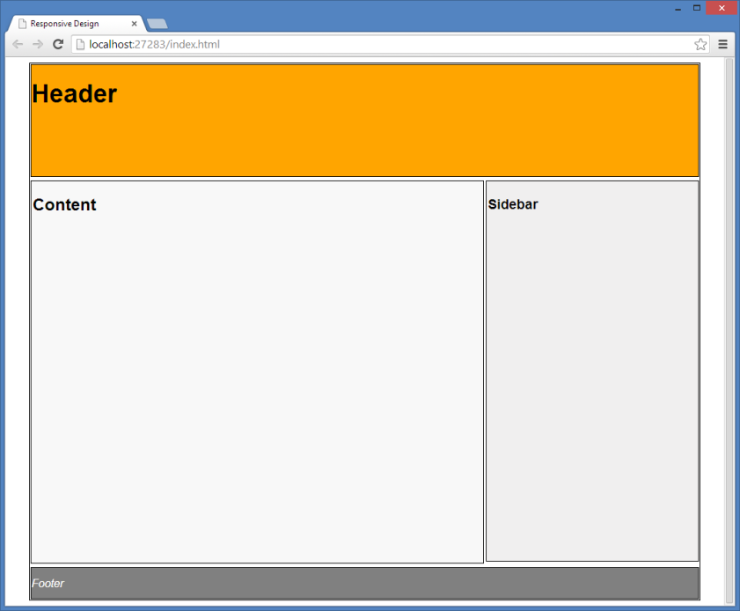

In the preceding figure, the layout is divided into three rows. Further, one of the rows is divided into two columns.

To create this type of layout using Bootstrap, you first need to create a container. Thereafter, you can add rows to the container.

For this, you can use the .row class, as shown in the following code snippet:

<div class="container">

<div class="row" id="siteheader">

<h1> Header</h1>

</div>

<div class="row" id="contentsection">

<h3> Content</h3>

</div>

<div class="row" id="sitefooter">

<h5> Footer</h5>

</div>

</div>

To see rows on a Web page properly, apply some style to the Web page, as shown in the following code snippet:

.container

{

border: 1px solid black;

}

#siteheader

{

background-color: orange;

height: 130px;

}

#contentsection

{

background-color: #fff;

height:500px;

}

#sitefooter

{

background-color: darkgray;

height: 50px;

}

To split rows into columns, Bootstrap provides several predefined classes, such as .col-xs-, .col-sm-, .col-md-, and .col-lg-.

These classes help you make grid layouts easily and quickly for different types of devices, such as cell phones, tablets, laptops, and large desktops.

For instance:

* The following table summarizes some of the key features of the new grid system for devices of different sizes.

|  |  |  |  |  |
| --- | --- | --- | --- | --- |
| ***Features of***  ***Bootstrap 3 Grid System*** | ***Extra Small Devices***  ***Phones (<768px)*** | ***Small Devices***  ***Tablets (≥768px)*** | ***Medium Devices***  ***Desktops (≥992px)*** | ***Large Devices***  ***Desktops (≥1200px)*** |
| *Number of column* | *12* | *12* | *12* | *12* |
| *Container width* | *None (auto)* | *750px* | *970px* | *1170px* |
| *Class prefix* | *.col-xs-* | *.col-sm-* | *.col-md-* | *.col-lg-* |
| *Column width* | *Auto* | *~62px* | *~81px* | *~97px* |
| *Gutter (gaps between column content) width* | *15px on each side of a column (i.e. 30px)* | | *15px on each side of a column (i.e. 30px)* | |

You also need to consider the following points about the Bootstrap grid system for creating the Web page layout.

* Every row in the Web page must be placed within or .ca .container ontainer-fluid for proper alignment and padding.
* You need to use the .row class to create the horizontal groups of columns.
* The website content should be placed within columns.
* Use the classes, such as .row and .cpredefined grid ol-xs-4, to create the grid layouts quickly.
* If more than 12 columns are placed within a single row, each group of extra columns will be treated as one unit, and will wrap on to a new line.

To create a Web page layout consisting of rows and columns using the Bootstrap grid system, you need to use the following code snippet:

<div class="container">

<div class="row" id="siteheader">

<h1> Header</h1>

</div>

<div class="row" id="contentsection">

<div class="col-xs-12 col-sm-9" id="leftpane">

<h3>Content</h3>

<br><br><br><br><br><br><br><br><br><br><br><br>

</div>

<div col-xs-12 col-sm-3" id="rightpane"><h3>Sidebar <br> &nbsp;</h3>

<br><br><br><br><br><br><br><br><br><br><br><br>

</div>

</div>

<div class="row" id="sitefooter">

<h5> Footer</h5>

</div>

</div>

.container {

border: 1px solid black; }

#siteheader {

background-color: orange;

height: 130px;

}

#contentsection {

background-color: #fff;

height:auto; }

#sitefooter {

background-color: darkgray;

height: 50px; }

#rightpane {

background-color:#aabbff;

}

#leftpane {

background-color:#ebf5f5;

}

* Once you have created the layout of a Web page by using the Bootstrap grid system, you can add Bootstrap’s built-in components in the various grid columns.
* You can copy the ready-made pieces of code from the following URLs:
  + http://getbootstrap.com/css/
  + http://getbootstrap.com/components/